6D5N YANGON–GOLDEN ROCK-BAGAN–YANGON

Day 1 | Yangon arrival - city sightseeing (L, D)
Day 2 | Yangon - Bago - Golden Rock (B, L, D)
Day 3 | Golden Rock - Yangon (B, L, D)
Day 4 | Yangon - Bagan sightseeing (B, L, D) (Flight)
Day 5 | Bagan sightseeing - Yangon (B, L, D) (Flight)
Day 6 | Yangon - departure (B)

DAY 1: YANGON ARRIVAL – CITY SIGHTSEEING ( -/L/D )
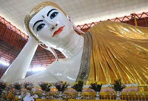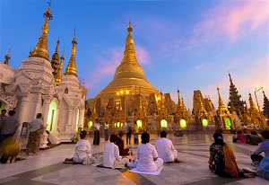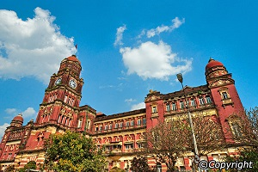
Chauk Htat Gyi pagoda Shwedagon Pagoda Yangon high court building

Upon your airport arrival, you will be greeted and welcomed by our guide and driver and then transferred to your hotel. After check in at your hotel and receive a brief freshening up before begin your city tour with us. It all starts with a visit to CHAUKHTATGYI TEMPLE which holds the biggest reclining Buddha statue in Southeast Asia.
Heading to YANGON’S COLONIAL part, soon you realize Yangon is a unique city, unlike any other of its size in all of Southeast Asia. It is Myanmar's commercial capital with a population of more than five millions. Take a walking tour to get a sense of Yangon's beauty with its picturesque lakes, verdant parks as well as its charming people. Then enjoy shopping at Scott’s market.
Afterwards, wander around Sule Pagoda which is Myanmar's oldest pagoda of 2,500 years old. During the day, you attention might be caught by the spectacular image of SHWEDAGON POGODA - patient, let's save the best for the last. When the sun sets, you will experience the wonder of this inspiring pagoda, being left breathless with its vivid color and sacred atmosphere. After a long day, take a good night sleep at your hotel in YANGON.

Accommodation: Overnight in Yangon
The distance: Yangon International Airport - Yangon city: 20km - 40 minutes for transfer.

DAY 2: YANGON – KYAIKHTIYO (GOLDEN ROCK) ( B/L/D)
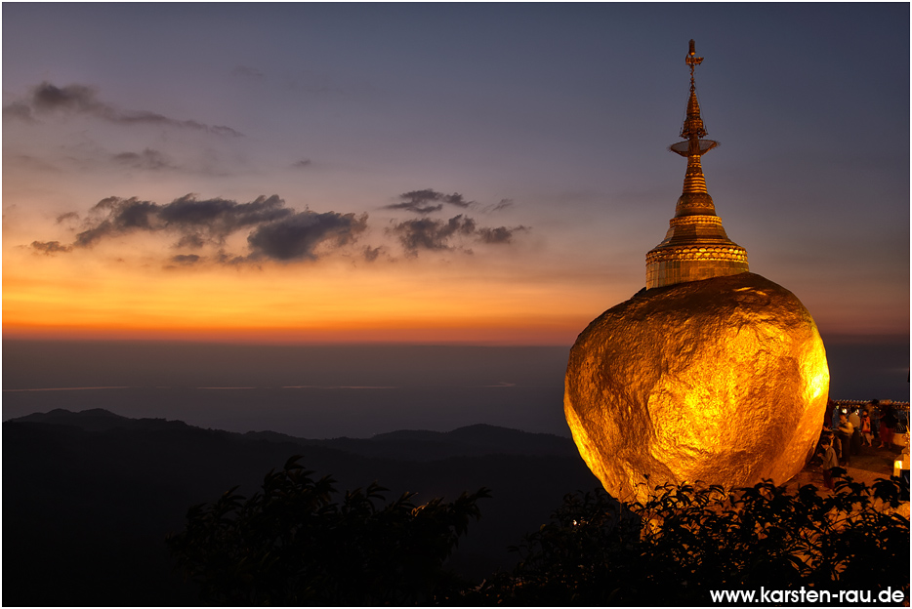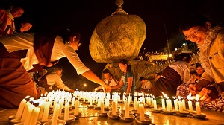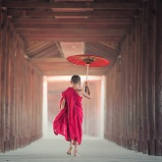
Kyaikhtiyo Pagoda Kyaikhtiyo Pagoda Burmese monk

After breakfast, drive to Kyaikhtiyo – the last domestic tourism center located about 160 km from Yangon to visit the miracle pagoda named Golden Rock Pagoda – enshrine a hair relic of Buddha. It is set on a top of gold gild bouloer which in turn is balanced on the edge of the cliff. The Kyaikhtiyo Mountain range is over 3645 feet above sea level. There are many legends about the pagoda and Nats (Spririt gods) shringe along the 11 km uphill. Cars/coaches reach only at Kinpun base camp and take the local open trucks (non roofs, non aircon) for 1 hr to the truck terminal near the foot of Golden Rock pagoda. Devotees believes that a pilgrimage to this pagoda brings them good health & wealth. Lunch at local restaurant. Dinner & overnight in Kyaikhityo.

Accommodation: Overnight in Kyaikhtiyo .
The distance: Yangon Capital – Kyaikhtiyo Pagoda : 160km – 4 hours for transfer & break time on the way.

DAY 3: KYAIKHTIYO – BAGO - YANGON (B/L/D)
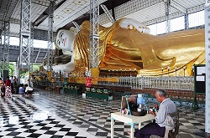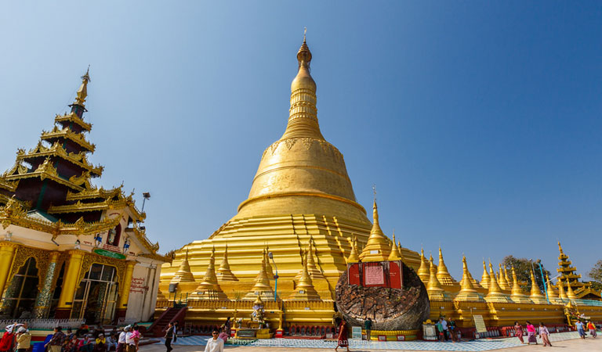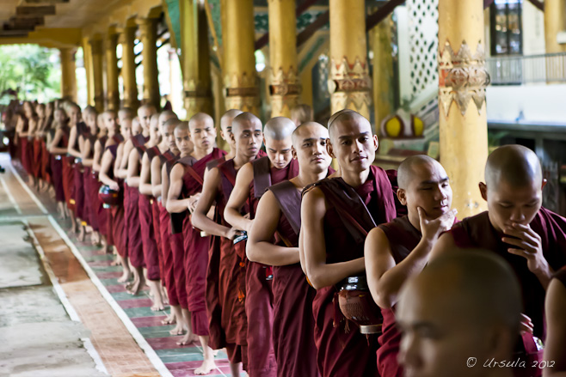
Shwethalyaung pagoda Shwe Maw Daw Pagoda Kyakhatwine Monastery

- After breakfast at hotel, drive to Bago – an ancient Capital of Mon Kingdom – 80km North East of Yangon. Bago Sightseeing Tour highlights include:
- Kyakhatwine Teaching Monastery where can see the thousands of student monks having their lunch or studying under the ways of Buddha Guidance;
- Chinese temple; Foot of Shwethalyaung Pagoda where can see the many vendors along the stairways & surrounding & can buy the varierty of Myanmar handicrafts & can observe the wood carving. Then visit
- Mon’s Weaving Village & Cheroot Making Home Cottage.
Driving back passing through the ral small villages & paddy fields.
Dinner at local restaurant. Overnight at hotel in Yangon.

Accommodation: Overnight in Yangon.
The distance: Kyaikhtiyo - Yangon Capital: 160km – 4 hours for transfer & break time

DAY 4: YANGON – BAGAN SIGHTSEEING ( B/L/D)
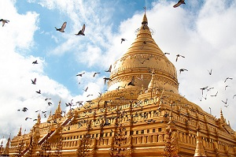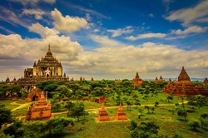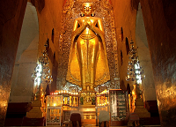
Shwezigon Pagoda Bagan panorama Ananda temple

After having breakfast, you will be transferred to the airport for a domestic flight to Nyaung U. As you arrive, we will drive you to your hotel in Bagan to check in. After that, discover Bagan - the land of thousands antiquated pagodas, one after another among green bushes. Start our trip by visiting SHWEZIGON PAGODA, the first gold pagoda built in Burma enshrining Gautama Buddha's relics and ANANDA TEMPLE, the home of four huge Buddha standing statues - each faces one of the four cardinal directions. Afterward, more temple visitations are carried out as we take you to GUBYAUKGYI TEMPLE at Myinkaba - an Indian style pagoda built in 1113 whose exteriors are still in good condition, HTILOMINLO TEMPLE whose name means "blessings of the three worlds" containing four Buddha images facing four directions on its first floor, and SULAMANI TEMPLE - a Buddhist edifice rebuilt in 1994 from which Htilominlo Temple was built after. Dinner & overnight at BAGAN.

Meals: 1 Breakfast + 1 Lunch + 1 Dinner
Accommodation: Overnight in Bagan.
The distance: Yangon city - Yangon Airport: 15 km – 40 minutes for transfer
Nyaung U Airport – Hotel : 8 km – 15 minutes for transfer

DAY 5: BAGAN SIGHTSEEING - YANGON (FLIGHT) (B/L/D)
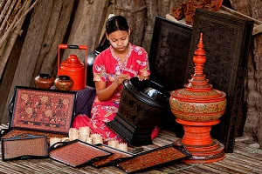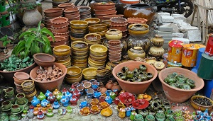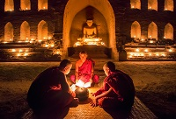
Lacquerware Nyaung Oo market Monks in Bagan
In the morning, head to Nyaung U Market where local products are boisterously bought and sold - you can get some real bargains there as souvenirs.
Then come to lacquer ware workshop to observe what they are made of. Next, visit Dhammayazika, a five-sided pagoda complex where in each side there is a small temple housing a Buddha statue.
In the afternoon, transfer to airport for a flight to Yangon.
Dinner & overnight in Yangon.
Meals: 1 Breakfast + 1 Lunch + 1 Dinner
Accommodation: Overnight in Yangon.
The distance: Bagan - Nyaung Oo airport: 8km – 15 minutes for transfer.
Yangon International Airport - Yangon city: 15km - 40 minutes for transfer.

DAY 6: YANGON - DEPARTURE (B)
Free time until transfer to Yangon International Airport for your departure flight.

Meals: 1 Breakfast
The distance: Hotel - Yangon International Airport: 15 km – 40 minutes for transfer

The ends of program!

SEQUENCE OF ITINERARY SUBJECT TO LOCAL ARRANGEMENT
PRICE INCLUDE:
Accommodation – as hotel in the list or similar – based on Twin/Double/Triple sharing
- Tour guide: English speaking guide during the tour.
- Shows and sightseeing in schedule.
- Transportation by private air-conditioner.
- Boat trips mentioned
- 01 bottle (500 ml) of drinking water for each pax per day.
- Meals (Burmese Food & Chinese Food) as the tour code ( B: Breakfast, L: lunch, D: Dinner)
- Domestic flights tickets
PRICE EXCLUDE:
- International & airport tax
- Camera fee
- Personal expenses: Tel, Fax, Mini Bar, Laundry,etc.
- Personal travel insurance
- Compulsory Tip for local guide and driver (USD/PAX/DAY)

Group Size | Tips in USD
2 – 4pax | 6
5-7pax | 5
8 - up | 3

- Surcharge with other languages guide.
- Surcharge at hotel case by case
  - Burmese New Year (TBA)
  - Gala Dinner on X’Mas (24 Dec ) & New Year 31 Dec

Hotel listed or Similar | All rates are next in USD/pax  valid for LOW SEASON from 01 May 19 to 30 Sep 2020
Hotel listed or Similar | Tour by private car / bus with private guide
 | 2 | 3-4 | 5-6 | 7-9 | 10-12 | 13-15 | SGL SUP
3* | 870 | 790 | 705 | 675 | 645 | 635 | 135
4* | 940 | 855 | 780 | 745 | 710 | 705 | 205
5* | 1050 | 965 | 890 | 850 | 820 | 815 | 315

Hotel listed or Similar | All rates are next in USD/pax  valid for HIGH SEASON from 01 Oct 18 to 10 Apr 19
Hotel listed or Similar | Tour by private car / bus with private guide
 | 2 | 3-4 | 5-6 | 7-9 | 10-12 | 13-15 | SGL SUP
3* | 950 | 865 | 790 | 755 | 720 | 715 | 160
4* | 1015 | 930 | 855 | 820 | 785 | 780 | 230
5* | 1165 | 1080 | 1005 | 965 | 930 | 930 | 380

 | 3* | 4* | 5*
YANGON | Grand United China Town 3*  Grand United donwntown 3*  Grand United Ahlone 3* | Taw Win Garden 4* | Park Royal 5*  Chatrium 5*
KYAIKHTIYO | Kyaikhtiyo hotel 3* | Mountain Top Hotel 3*+ | Mountain Top Hotel 3*+
BAGAN | Yadanarbon Bagan 3*  The Regency 3* | Amazing Bagan resort 4*  Myanmar Treasure Resort 4* | Bagan Lodge 5*  Aureum Palace 5*

NOTE
The timing of sightseeing points shall be fixing by local operator due to traffic and weather conditions, however all points must cover unless amendment or cancellation make by clients themselves (Non-refundable for any cancellation that made by clients)

Tour and price are subject to change without notice or incase of deduct number of pax in quoted group.

Small deviations in the tour program are sometimes necessary, depending on weather, road conditions, flight schedules and room availability.

Supplement charge for room rate in peak dates depends on the hotel category used. Compulsory gala dinner on X’mas, New Year’s Eve to be advised upon booking. Prices for group of 15 persons up in 5 stars hotels sometime requires to re-quote bases on the hotel policy

Group tour 20pax, you will get 01 FOC for tour leader based on twin sharing basis include breakfast (domestic air ticket is not applicable)

BUS

Group Size | Kind of Transportation
1-2 pax | 4 seater
3 pax | 7 seater
4-9pax | 16 seater
10-18 pax | 30 seater
19-21 pax | 35 seater
22 – 42 pax | 45 seater

CHILD POLICY

- Infant below 2 years old sharing same room with parents is free of charge.
- Child below 12 yrs old sharing same room with 1 ADL is charged for 90%.
- Child below 12 yrs old with extra bed and sharing same room with parents is charged for 65%.
- Child below 12 yrs old No extra bed & sharing same room with parents is charged for 55%.

TERM & CONDITIONS

1. CANCELLATION
In case of cancellation, fees will be charged accordingly to the day that official notice in writing is received at Hanoi Office: No 11, lane 8, Doi nhan, Ba Dinh district, Hanoi-Vietnam.

- Before 30 days: No charge
- Less than 30 days: 50% of total tour price
- Less than 14 days: 75% of total tour price
- Less than 7 days before arrival date or no-show: 100% of total tour price

Any cancellation due to irresistible reasons such as wars, strikes, earthquakes, etc. will be considered subject to each case.

